09:00 – 09:15 Welcome

online conference on open climate information for the biodiversity and ecosystem services community
- Welcome
- Agenda & etiquette

09:15 – 10:15 Biodiversity & Climate
Introduction to the interplay between Biodiversity, ecosystem services and Climate (change)
Climate Information for Biodiversity  22/10 | Virtual conference | 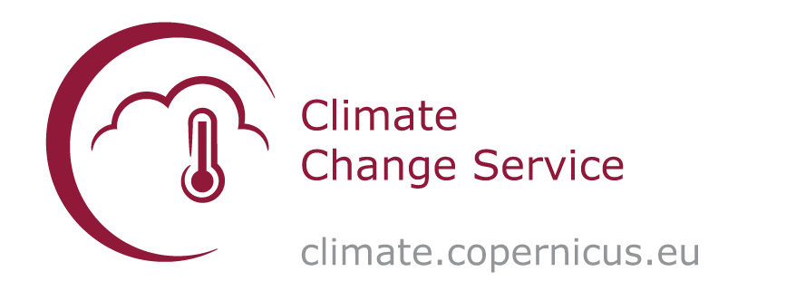
- Biodiversity and climate (change) by Hilde Eggermont, Biodiversity Platform Belgium

- Importance of climate information for biodiversity conservation & the Copernicus Climate Change Service (C3S) by Samantha Burgess, Deputy Director C3S (Copernicus – ECMWF)

Interactive intermezzo
10:15 – 10:30 Break

10:30 – 11:00 Demonstration of the Copernicus Sectoral Information System (SIS) Global Biodiversity
Demonstration of the open climate information service for biodiversity
- Introduction to the Sectoral Information System (SIS) Global Biodiversity by Koen De Ridder (VITO)
.
- Climate explorer application by Hendrik Wouters (VITO)
- Climate suitability explorer application by Hendrik Wouters (VITO)

Interactive intermezzo

11:00 – 12:00 Biodiversity use cases
Deep-dive into SIX biodiversity use cases
Two parallel sessions with diverse biodiversity cases and how climate data can promote their progress

Session A
- Climate suitability for grassland species in Latvia (BEF-LV)
- Sea ice indicators for seal reproduction in the Baltic Sea (BEF-EE)
- Thermal suitability for fish species habitats (DTU-Aqua)
Session B
- Climate suitability for tropical tree restoration in Central Africa (Bioversity International)
- Climate suitability for Golden-headed lion tamarin habitat in Brazil (KMDA)
- Climate suitability for European hedgerows (Arcadis)

12:00 – 12:15 Closure
Are you in for more? Explore the service yourself in 2021!

09:00 – 12:15 Continuous online networking & poster booths

